**Lab 4 – Databases**

1. Create a new table (if you don’t have it already):

CREATE TABLE `phonenumbers` ( `PersonID` int(11) NOT NULL, `PhoneType` varchar(10) COLLATE utf8_bin DEFAULT NULL,

`PhoneNum` varchar(8) COLLATE utf8_bin DEFAULT NULL,

`AreaCode` varchar(3) COLLATE utf8_bin DEFAULT NULL ) ENGINE=MyISAM DEFAULT CHARSET=utf8 COLLATE=utf8_bin

1. Copy the mysqli people.php class script from class and name it: Lab4_1.php. Use the DB.class.php file.
2. Create a new script Lab4_2.php.
3. Change the DB.class.php script to change the links that are created currently in the method that returns a table linking to phones.php to link to Lab4_2.php.

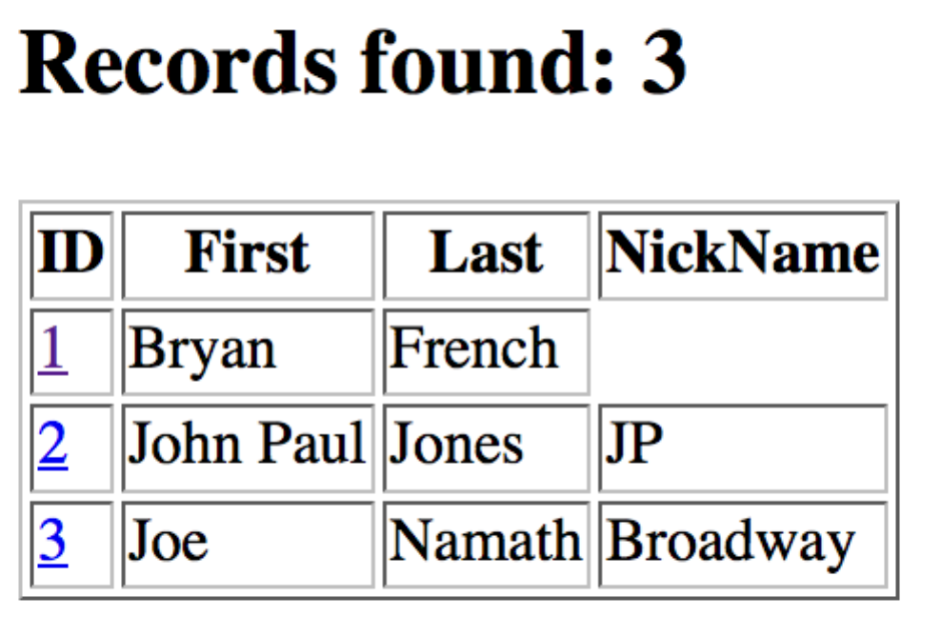

1. Make Lab4_2.php redirect back to Lab4_1.php if an id is not passed to the script via the URL.
2. Make Lab4_2.php, display all of the phones for the selected person (get ID from URL) with a link back to Lab4_1.php. Use mysqli parameterized queries for all queries:

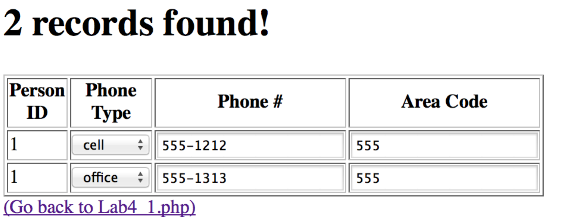

1. Copy Lab4_1.php and name it: Lab4_3.php. Make the script link to Lab4_4.php instead of Lab4_2.php. Use the PDO.DB.class.php. You will have to duplicate the method that returns a table from the mysqli version in the pdo version making the appropriate changes as below.



1. Create a new script Lab4_4.php.
2. Make Lab4_4.php redirect back to Lab4_3.php if an id is not passed to the script via the URL.
3. Make Lab4_4.php, display all of the phones for the selected person (get ID from URL) with a link back to Lab4_3.php. Use pdo parameterized queries and PDO::FETCH_ASSOC for all queries:

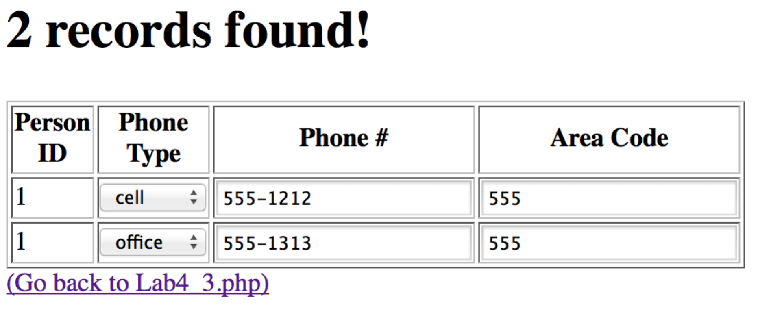

1. Repeat step 10 and add an html table, but use the PDO::FETCH_CLASS to do it. You will need to create a class for the phonenumbers table. Lab4_4.php should display 2 tables now that look like step 10.

